

Bank of England

Inflation Repor t

May 1993

Inflation Report

May 1993

Recent price developmcnts

.1 Retail prices **Manufacturing prices** Domestic deflators **‘Core**

1.5

1. Monetary and fiscal policy 12
   1. Monetary conditions

Interest rates

The exchange rate

Monetary and credit aggregates I6

2.2 1 p ie 18

*Divisia indices for monev*

Demand and output 20

Output and the output gap 20

**3.2 Demand** 22

Personal sector debt, gearing and

the housing market 22

Overseas trade 24

Survey evidence 26

Price dynamics 27

**The labour market**

Earnings and settlements

Labour productivity 29

Unit wage costs 30

30

Business margins and the return to

30

Profitability 30

Business mark-ups

##### Import prices 32

Measurement of import prices 32

Commodity prices

l’rospccts liir inflation

###### Surveys of inflation expectations

* 1. Evidence from financial markets:

‘Break even’ inflation rates 36

Outside forecasts Bank projections

The short-run outlook VAR models of inflation

Longer-term structural projections 39

42

Reprinted from the May 1993 Bank of Eng and 9 *'erly B*

Printed 6y Burrups Ltd & Bank of England 1993 ISBN 1 85730 091 2

Summary

The *Inflation Report* contains the Bank of England’s analysis of recent changes in inflation and the prospects for the future. It contains six sections covering: (i) recent price developments;

(ii) monetary and fiscal policy; (iii) demand and output; (iv) price dynamics; (v) prospects for inflation; and (vi) conclusions.

Compared with three months ago, it is now somewhat easier to see how .last autumn’s depreciation is affecting domestic prices. Retail prices of a number.of products, including some food items and consumer durables, have risen more rapidly since the autumn.

And the latest three-month inflation rate has increased a little since the last *Report* and now stands somewhat further above the

twelve-month rate than was the case three months ago. NevertheleSs, underlying inflation, at 3.5%, is still in line with our expectations in February.

Inflation, as measured by RPIX, has remained within the target range throughout the period since the February *Report.* During that period new information about the likely course of future inflation has been of three main kinds. .First, levels of real activity are rising more rapidly than had been anticipated three months ago. Most of the indicators relating to the real economy, including output, retail sales and employment, point to increasing levels of activity. Second, the exchange rate. as measured by the sterling effective exchange rate index on 7 May, is some 5% above the level at the time of the February *Report.* Third, in the March Budget the Chancellor announced increases in indirect taxes, to take effect both this year and next, which will raise the measured rate of underlying inflation. The rise in the exchange rate is not independent .of the news about activity, indeed in large part it follows from it. This increase in the exchange rate has lowered somewhat the risk of breaching the top of the target range towards the end of this year and the early part of next.

The projections for the next three months show inflation declining in!April, but then rising to 3.5& by June. The initial fall largely reflects the impact of the change from tlie Community Charge to the:Cpuneil Taa. The.subsequent rise is expected to be broadly based;, and Associated with:the direct pass-through of higher import prices into:nooie8nG. retail prices:

3:.

##### On balance, the changes since the last *Inflation Report* have lowered slightly both the expected inflation rate and the probability of breaching the 4&» limit during the course of this year. The impact next year of the Budget measures, together with the uncertainties surrounding the rate at which the output gap is likely to narrow, suggest that the probability of breaching the target next year may be a little greater than previously envisaged, but the Bank’s central expectation still is that the target will be met. Any further increase (decrease) in the exchange rate would lower (raise) the probability of breaching the target.

Expectations pf inflation in the future are not yet consistent with the target range for inflation of l %—4&a. Both direct surveys of expectations and also the indirect.evidence from implied forward market interest rates suggest that many economic agents have yet to be convinced that the target wih be met in the long run. But the longer underlying inflation remains within the target range the more credibility will grow over time.

###### Looking to the end of 1994 and beyond, the principal uncertainty concernsihe response of domestic factor costs— wages and profits to the loss of purchasing power resulting from depreciation of the currency. If total profits and wages rise because of a *volume* effect, rather than an increase in profit margins per unit of output or earnings per head, them the increase in.nominal demand consistent with the monetary stance will lead to rising real activity and.continuing low inflation.. A continuing determination on the part of the authorities to meet the inflation target will help to ensure that increases in wages and profits are real increases, reflecting higher output and productivity, rather than nominal increases reflecting only higher unit costs. It is vital in this context that the inflation target be seen as a framework for policy over a long period, and thai monetary and fiscal policy should he consistent with achieving the target on a sustained

.basis.







**Inflati0n**



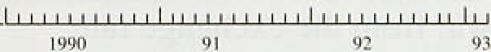

Inflation is a rise in the *general* level of prices. When there are significant changes in *relative* prices, the various measures of inflation may give different estimates of ‘the' rate of inflation. This is particularly relevant following a depreciation of the

currency—the effective sterling exchange rate fell by more than 13% between the first quarter of 1992 and the first quarter of this year—when retail prices will rise to reflect the one-off adjustment of domestic prices to the higher costs of imports. In principle the **GDP** deflator, which measures the rise in the price of domestically produced output, offers a better guide to

.underlying inflation. But, because there are time lags between changes in the exchange rate and the response of prices in the home market to increases in

, import prices, the .GDP deflator is itself a misleading guide to underlying inflation at exactly the time

* when it might be thought to provide a more accurate signal. Indeed, the **GDP** deflator (measured at factor
* cost) fell by almost 19r in the fourth quarter of last year, when import prices rose but were not
* immediately reflected in higher prices at home. And the deflator is likely to rise during 1993 to compensate for this fall. These arguments strengthen

, the case for .defining the official inflation target in terms of the increase in the Retail Prices Index

— • excludin ge interest payments. Measured in this way the outtum for inflation is available promptly and is easily understood, thus enhancing accountability. It is, however, affected by changes in indirect taxes which, following the March Budget, will lead to higher measured inflation than would otherwise have been the case. For these reasons Section 1 discusses recent changes in different measures of inflation in the United Kingdom.





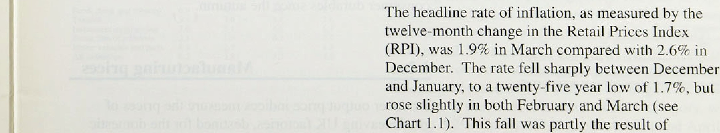



**C"ltart ].2**

**C"‹›xs'entit›nal measures ‹›f’ inflation**





reductions in mortgage. interest rates; which fell by!.an average of one percentage point betweenl£iecember and Mareh. But the underlying ate of inflauon tlie! increase in the **RPI** excluding mortgage interest payments **(RPIX** also fell from 3.7&o in December to 3.5&• in March.

As Chart 1.1 shows, iñflatioñ fell most rapidly between mid-1990 and mid-1991. Thereafter the headline rate

_ fell only very slowly until the latter part of last year.

The underlying rate, by contrast, showed a steady

‹ reduction from April of last year which only came to an end with the increases in February and March this year.

— As Chart 1.2 shows, the decline in the underlying rat‹i was broadly based, and held in both services and goods.

**Shurl-run measures of’** inflation

RPf RPfX Gucds Service

|  |  |  |
| --- | --- | --- |
| 4.7 | 3.6 | 7.3 |
| 2.8 | 0.fi | 4:S |
| 3.I | L6 | 4.9 |
| 39 | 2.7 | fi.1 |
| ktarch I 0'73 I .0 4. I | 3.9 | 6.4 ’ ’ ” |



£”hart I.ñ

ftecent remit price duvcInpnzcnt.s











Very recent price developments are captured rather poorly, however, by conventional measures which record. the .change in prices over.the previous twelve months.

Table 1.A shows price changes recorded over

three-month periods for each of the series shown in Chart 1.2. The figures .have been seasonally adjusted and then annualisN to ease comparison with the chart. The figures are sensitive to the choice of seasonal adjustment technique, .and are clearly more volatile than the conventional twelve-month measures. But they provide an insight into recent changes in. inflation.



Short-run underlying .inflation has risen slightly s-ince three months ago. At an estimated 4.1m it is a little above: the conventional twelve-month measure and well above the short-run rate in the period .immediately before sterling’s withdrawa!l from the .exchange rate mechanism. The short



prices also reached a trough during this period and has picked up quite sharply since then.. The impact of devaluation would be expected to show up earlier in the prices of goods than of.serv.ices because i!mports constitute a greater.proportion of finallexpenditure on goods than of services. Nevertheless,.shon-run changes

i.n the price.of services have!!also!increa’sed recently. The effects of devaluation were first visible in petrol prices but„as. can be! seen in.Chañ 1..3, there:ihas altolbeen

some acceleration in..food.prices and.the priyes of consumer ldunibles sine.e the autumn.





##### goo‹is.flaying UK factories, destined for the.domestic

6

.market. These can be compared with UK producers’ export prices. To the extent that the two indices refer to the same goods, they indicate the scale of price discrimination between home and export markets.

During late 1990 and early 1991. after sterling’s entry into the ERM, export prices were rising at a much slower rate than domestic producer output prices. Since then the pattern has been reversed, with sterling export prices rising sharply following sterling’s depreciation last autumn.



Chan I.S

_ 3

Excluding the food, drink and tobacco sectors. the twelve-month increase in producer output prices has stayed at around 2'/ % to 3% since the beginning of last year. This followed quite rapid declines during 199 l ; producer prices had been rising at over 6'« in the year to 1991 Q1. Shorter-run .measures show a clear pick-up in output price inflation (excluding food, drink and tobacco) since the end of last year. In the three months to April, output prices rose at an annualised rate of’ 3.2&•

**Manut'acturing export and producer** priCe



- 8



— — 2'





* T bIe.1.B

**Sectoral,cbaoges.ia producer** oufisut prices



###### compared with an equivalent rate of 1.8% in the three

months to December (see Chart 1.4).

Export prices have risen rapidly since last September, as can be seen in Chart 1.5. From January of this year. export price data have been available only for non-EC trade, and these show a twelve-month increase in manufacturing prices of 11.29c in March, up from 1.69• in October. Shorter-run measures indicate more clearly the extent to which prices have responded to the depreciation. Between September 1992 and March 1993, export prices (total trade) rose by 10.9%, after rising, by only 1.1 to in the previous six months. Since sterling has .depreciated by rather more against the dollar than against the European currencies these estimates may be higher than the equivalent figures including trade with EC countries.

Turning to the sectoral composition of changes in manufactuñng prices, the rates of change in the

sub-components of producer output prices show some variation.. At the two-digit level of the Standard Industrial .Classification (SIC) no component was showing more than,a 6% increase in the year to April (see Table .1.B),,and most were in the 1'/zoo—4&o range. Indeed, the extraction of minerals category, which sliqwed.a:2:7% .decline over.the same period,.was one of only:two components to show a.twelve-month fall,.

.8itiee the .depreciation of stprling the largest **increase**

hwheen:in1the **food,,** drink **and.toñwco** ategoyy, .which. by S.2U unadjusted between A*gust and April,.

7



with other large increases. in electrical and electronic engineering and miscellaneous manufacturing..

* 1. **Domestic deflators**

Tahte I .I"

**Domestic deflato xpenditurr components**

GDP Consump- \nvcsi- Govern- Esp.arts fmpuns





1991 Q I b. 1 7.* 2.2 9.5 tLh fi.3

Q2 Cd 6.7 -U.4. 7.8 1? -12

Q] t9 6.H -l9 6J 0.4 -

Q4 4.9 6. 1 ? 5 6.1 -0.5 0.1

I09Z Q I 3.2 61 -44 6.6 L7 0.3

g2 15 ñ3 -17 64 02 0.9

Q3 4.5 J4 -4. I 7.0 - LS -2 I



SeasonglI} adjusted q\iartcrly growfk rures

Q1 on Q3 0.4 (I.7 -.0.5 1.fl -1.7 -0.5





The GDP deflator is an index of domestically generated inflation. The deflator fell in the fourth quarter of 1992. Measured at factor cost (that is, excluding indirect taxes) it was 0.9% lower than in the previous quarter, bringing the annual inflation rate down from 4.SP to 2.3%. The slowdown in this implied inflation rate

during 1992 was associated with weak investment and export prices in particular. But the sharp fall in the *level* of the deflator in the fourth quarter reflects the rise in import prices. Sterling’s fall pushed up import prices sharply, leading .to a rise of almost 9% in the fourth quarter. In most circumstances, this rise would result in a rise in the .deflators for other ex enditure comPonents,

###### leaving the overall GDP deflator unaffected. But during

a period when demand is weak, firms may choose not to pass on import price rises immediately. In particular, domestic importers, whose part of total value added, may have decided to absorb some of the devaluation in those margins, reducing the rise in the GDP deflator in the short term.



Overall, however, the picture is not quite as encourageing as in the previous quarter. Table 1.C shows that consumer price deflator inHation is still above 49c and accelerated in the fourth quarter. Investment prices are beginning to rise again, and. inflation in the deflator for public consumption remains high, though the effect of the 1'/i& pay .ceiling has yet to come through.

**Table I.D**

**Domestic deflators—cost components**

Wage Co arty Other Inn.pop

props tncome pneo

l ft creasc on a year earlier: .

Ge"fla’tor

The GDP deflator can also.be.constructed from its cost rather than expenditure components1and this highlights the role played by firms’ margins. Table 1..D, shows labour costs, company profits, import:costs, airesidual category ‘other income’ (which includes gross trading surpluses of public corporations and general government

I 99l g'l 10.4 -5.7 IO. I -4.3 8, a



Q3 ?1 -g,7 74’

Q4 6.3 -2.0 4.g :0J

1992

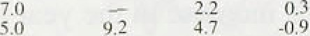

Qi

enterprises, as well as income from rent.and self employment,.excluding stock appreciation) and thg GDP deflator. There rhas been.a.0rainatie’fa1l,in!.unft labour cost increases since.the.beginning.of 199.1.

However, particularly ifi:its eârly stages, ,the recession ”





also bore down heavily rim profiu (or firms’ margins), shown in the second’c91umn.of Table 1.D. Attempts



* 1. **‘Core’ inflation**

Chart I.6

**Measui-es of ‘core’ inflation**





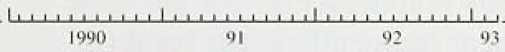

The argument for moving from a broad measure of underlying inflation to a narrower measure of ‘core’ inflation derives from the problem of distinguishing changes in relative prices from changes in the price level. Large changes in relative prices can provide a misleading impression. They often result from temporary .fluctuations of comparatively narrow groups of prices, such as seasonal foods and petrol. Stripping out the more volatile components of the RPI, and those components which directly reflect the Government’s policy actions, will produce an index which is less representative of actual price changes but which may offer a more accurate guide to movements in the trend. Chart 1.6 presents two alternative measures of ‘core’ inflation alongside the standard measure of underlying inflation. The two ‘core’ measures have moved closely with underlying inflation since the February *Report.*

Both measures recorded sharp falls in January and both " have risen slightly since then to rates just below those

for December.

The definitions of 'core’ inflation shown in Chart 1.6 are essentially arbitrary. Some authors, however, have proposed a more theoretically based approach to the measurement of ‘core’ inflation in which individual price changes are ranked for each period and then selected or rejected for inclusion according to some

.agreed criterion. The technique is a very simple one, and may best be thought of as producing a median inflauon rate, or an average over the less volatile components of the index (the ‘trimmed mean’ ). The box on page 10 presents estimates compiled from 74 components of the RPI. Although median inflation rose fractionally between December and March, it has the same general characteristics as underlying inflation and is currently coincident with it.



These measures are interesting, and deserve further investigation. However, the risk remains that, in stripping out large price movements, the resulting index may be unrepresentative. The Housing Adjusted RPI (HSRP.tndex) includes all of the items in the RPI with one exception. It replaces the mortgage interest component of the headline RPI with an alternative

##### qser-0osr-of-capital measure!of owner-.occupied ho.using costs. The!construction.,of the measure was described in

 the February Jn ***offon!?teport.*** The HARP measure of inflation has!risen by 0.4 percentage points since three niontbs,ago. At 1.8R, it. Inai!nsjust.below .the headline

##### — RPI.zatnhaving been 1.2 percentage points below the







Measures of core inflation strip out sorñe of the chânges’across goo’ds.and services would be

more volatile components of the RfiI! in order!to bunched aromid’this underlying rate. .If/there.were. reveal. the iinderlyirig.trend: But there rnoy .be less .a few largeractiial price changes, then the average

.arbitrary utay.s,of measuring.core.inf1ation,than :raie:would be pulled away frorñ the underlying rate.

simply stripping out parli*u!ar:series su‹:h as

mortgage interqst: pnyments„..administered.prices or The. ehârt shows.a (weighted) .median rate of food.anñ energy. One.alternative is to! use. inflation.!derived from observations on 74

statistical rrtethoiJg to smooth put short-term

fluctuations in the RPI. But these .metho;1s are also

components of.the RPI. It:.sho,ws also the average inflation.rate of the Annal 7O&».of the distribution

arbitrary. They might generate a less volatile of price.changés- .This ‘trimméd-rñean' excludes series, but there is no clear reason to suppose that some of those éhânges **in prices** which would not

be compensated for.by. ,smaller changes in the

 **Ill J*ltfflll It llf flJt•11S1J fi1** S (fi t **Alt’ *tflP9’ f"'** • opposite .di:Section.be**cause.** of tlie riienu costs... **The**

proportion.of the dis ibution which is excluded is arbitrary.

" " '""*“"’

The table illustrates.how often certain:components appear in the ‘trirninéd.mean’: .The components

' : . . . .

chosen are examples of!ty:pes of commod!ity which

— , might be expected to bé excluded from .’‘core’

indices (eg. foods; administered priées, energy.

* + — , products etc). One of the grounds. for excluding mortgage interest payments (MIPs) front tfié:RPI is.

— that MIPs.are unusually volatile: (d.e.pen‹Jing !argel'y on the level of interest rates). Tliere is support(on

* + , — ‹› this in the table, since. MfPs .nl;nost.never appeal i:i.

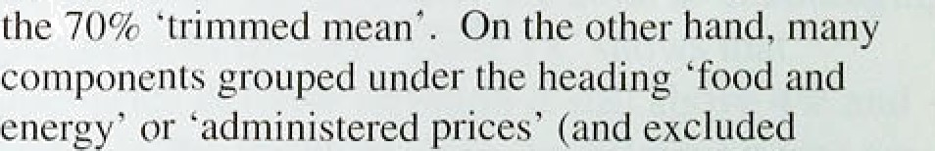



underlying irit4ation itself is not volatile. Another from the RPI by ifiany commentators for the same measure of core inflation; due to Bryan and reason).actually appear frequently in the band (in Ceéchetti,*' is1 based ori the idea!that a significant some cases.. they!,are .sever excIu‹ied). Theitable proportion ofi fiskms..face costs of adjusting prices suggests tfiat:excluding soine goods for all! tirtie on (’menu .costs’). .In such circumstances,..changes in the grounds of volatility alorie is riot sensible, relative!prices.cañ affect the. aggregate.price level,

RPI **suli sections and their appearance in the 70 &c ‘lrinimed mean’ (Januars’ 19118-4Iarch 1993)**

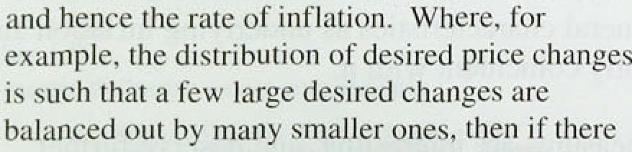

1arge

' Orscripiion. Number of appearances itt 70a 'iiinimed mean’



measured b.y. the average, show up aG air increase ih, the. price level, even though the underlying.rate of inflation would not have changed. In such

Mongagg in'IcreGi p:iytneiiis 'Ralcs/C'ummunity.Chnrgñ



DIY iraierials El'cctrici Iy Gas



.circumstances, one way to uncover tire..underlying rate of inflation is to choose the median inflation rare .among **goods** an‹J **érviées. Since.** iño t

Télephones'eir.

.„.'75

Purohnsc.ñf nJoior:.vehicles

Pctroltan'd:owl:”

e’

over and

.' 7g' '.



inn



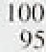2

21,

59





:





headline rate in December (see Chart 1.7). The contrasting behaviour of these two measures since December is partly related to house prices which rose by

0.69 between December and March and which are captured directly in the HARP index but not in the **RPI.**

Chart 1.7

RPI »d HARr i»n»i:on rates



oivner•occupation t uninp unadjusied Hal i tax house price iiidez i.

One other price index which is of interest is the Tax and Price Index (TPI). This measures the change in gross income that would be needed to allow a household to continue purchasing a representative bundle of goods,

” taking into *account not* only changes in *prices* but also

„ changes to direct taxes. The switching of the tax burden from direct to indirect taxes in recent years has

, contributed to the measured rise in the average level of prices. However, the change in gross income needed to

‹ compensate for this increase has typically been less than one-for-one. And in the year to March the rise in the TPI was just 0.7%.

## 1 5 Su

Compared with three months ago. it is now somewhat easier to see how last autumn’s depreciation iS affecting domestic prices. Retail prices of a number of products, including some food items and consumer durables, have risen more rapidly since the autumn. And the latest three-month inflation rate has increased a little since the last *Inflation Report* and now stands somewhat further above the twelve-month rate than was the case three months ago. Nevertheless, underlying inflation, at 3.5%, is still in line with our expectations in February. Judging the balance of pressures in the coming months requires an examination of the forward indicators of prices. It is to these that we now turn.

 

Section l discussed recent developments in a range of price indices. The rest of the *Aeporr* considers the factors which will determine inflation in the future, in both the short and long run.

The February *Inflation Report* Bet out in general terms the Bank’s view of the .inflation process. Inflation is a monetary phenomenon: more rapid monetary growth will, other things being equal, lead to more rapid inflation. But the transmission from changes in monetary policy to changes in the rate of inflation is a complex process which is likely to change over time. Identification of the impact of a panicular monetary shock is thus unlikely to be straightforward. There are also considerable problems in identifying the monetary shock itself, since measured monetary aggregates are .all subject to some theoretical or practical difficulties (see the article on page 240 of the May *Quarterly Bulletin* and the box on page 14).

Analysis of inflation begins, therefore, with an analysis of monetary policy, both present and anticipated.

Although monetary policy may be analysed in terms .of changes in the monetary aggregates nd some discussion of these appears in Section 2.1—the primary instrument of monetary policy is short-term interest rates. It is also the primary channel by which monetary policy has its impact on the economy, although the. impact of any given change in the short-term interest rate will depend, in part, on the extent to which the change is reflected in longer-term interest rates. This in turn will depend on expectations of future monetary policy. Since the autumn, the inflation target has been the objective to which monetary policy is directed, and if the commitment to the target is fully credible then the authorities would be expected to respond to any prospective movement of inflation close to the limits of its target range or beyond. The credibi!lity of the authorities.’ commitment to the .inflation.1.target can thus be judged by examining .the markete' expectations of future interest rates. This is discusse‹i in Secfion 2.1.

One important determinant of expectations is **fiscal** policy. **Changes** fn **.fiscal** policy would be.1expected to result in shoyt-.run changes.in, output anal pnces. Birt if

.monetary poliéy.does not accommodate the resultin

changé. i!n.prices then Escal **policy** of itself should iiave

12.



**Table 2.A**

**Off'icigl interest rates overseas**

f¥92 1993

|  |  |  |  |  |
| --- | --- | --- | --- | --- |
| I Sept. | I Dan. | I Mar. | 1Apr. | 7 May |
| 6.0 | 6.0 | 6:0 | 6 0 | 6.U |
| 3.0 | 3..0 | 3.u | 3.0 | 3.0. |

’ Prim Discount

no long-run impact on the price level. But large and persistent deficits may cause investors to fear that the authorities will be tempted to erode the real burden of debt by inflation. In this way, fiscal policy can have a significant effect on expectations of monetary policy and

thus of longer-term interest rates. Fiscal policy is discussed in Section 2.2.

## ne t



€ieriiany:

3.25 3.25 2.S 2:S 2.3

4i I 3.9 3.z 3.2 3.2

###### Official interest rates in the United Kingdom have

Discount 8:75 .8.25 8.0 7.5 7.25

Lombard 9.75 9.5 9.0 9.0. 8.3



ttaly:

Distouni 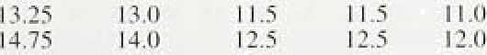



**Expected 3-month sterlingiLibor rates**

t993 1994

Dale Sri June Seri. Dec. Mar.

14.5ep\'.1992 10:25 9:5 9.2 9.2 9.

21 ;Sept. 9.23. 8.0. 8:0 8.3 8.S



7 May ’ ’ ’ 6.0 4.U 59 6.0 6.3



Chart 2.I

**Implied** forward **interest** rates







remained unchanged since the one percentage point cut—from 7&r to 6%—on 26 January. By contrast, official interest rates in some other European economies have fallen (see Table.2.A). In Germany, for instance, the Lombard rate was cut by 0.5 percentage points in April. and the discount rate has fallen by 0.75 percentage points since March. In France the reductions have been bigger as exchange rate pressures have eased considerably. Although the intervention rate has declined by just over one percentage point, the 5—10 day repo rate has fallen by three percentage points.

Following the last interest rate cut the markets were discounting a further cut in three-month interest rates of around 'f4 percentage point by June. But by early May sterling interest rates (as derived from interest rate futures prices) were expected to remain broadly flat this year, with a possible rise in early 1994 (Table 2.B). In the United States, too, short-term interest rates are expected to rise as recovery takes hold: three-month rates are expected to increase by around '/i percentage point, to 3.6%, during the remainder of this year.

European interest rates, on the other hand, are expected to fall further as monetary authorities respond to falling inflation and .the slowdown in growth. Three-month euromark rates, for example, are expected to fall from 7'fi& on 7 May to just 6&o by the end of this year.

Although.sterling interest rates are:now expected to be higher in the near future’than was thought likely at the time.of tñe last *Inflation Report,* expected interest rates liave acuially declined at all maturities beyond six years.

.Chart *2:1.shaws:implied* forward interest rates.on 7 May;.

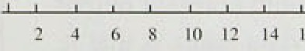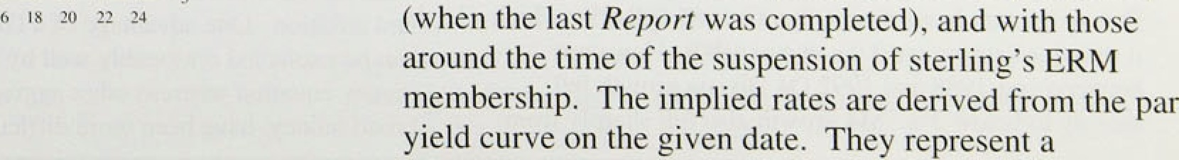

\ 3

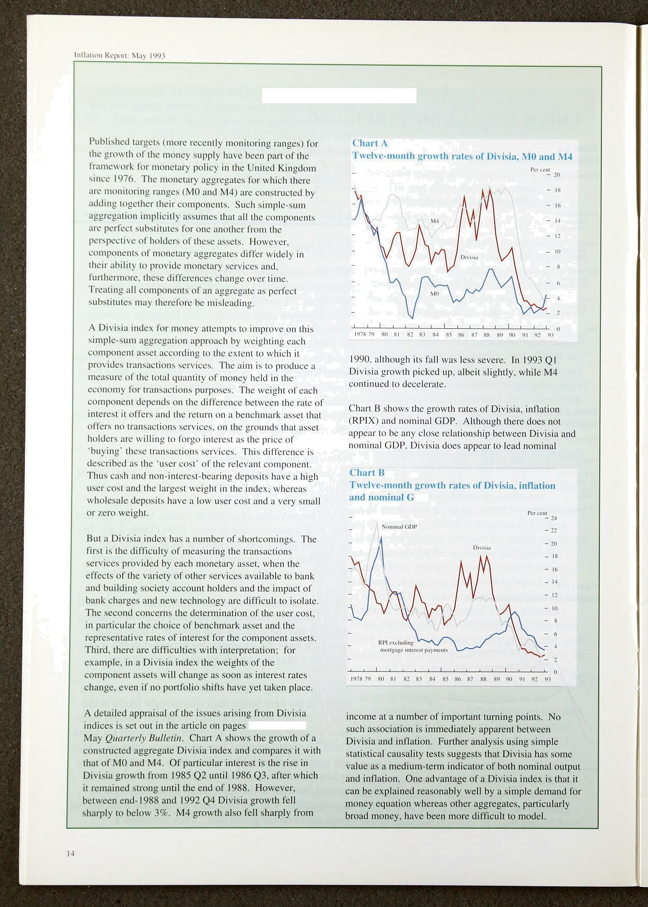Divisia indices for money

240—55 of the

succession of one-year interest rates at future one-year intervals which would, if realised, yield the same return aS lthe relevant longer yields on the date in question. If the term risk premium is small, these implied rates can be interpreted as expected future short interest rates.

The yield curves from which they are derived are

###### calculated by fitting curves through observed yields on

a large number of government bonds. As a result the

.shapes of the implied forward yield curves are sometimes difficult to rationalise. The most recent curve in Chart 2.1, for eKample, shows some slight fluctuation beyond the nine-year maturity, and there is no obvious economic explanation for this. Hence the curves should be interpreted as illustrating expected general trends, rather than offering precise estimates of expected yields.

**Table 2.C**

**The sterling exchange** rate'*›

1 fi Sept.: 31 Dec: 3. Feb:t6I 7 i\4ay

Suiting ERlfti 90:9 79.6 77.7 80,9

US aollar I: 89. 1,52 I.43 1.58

Deu'rschmark 2.GB 2,45 2.4\7 2.49

SDR ':l,31 1.10 1.06 1. I I



(c) 1985= HD.



In this spirit, the most recent data show that interest rates are expected to rise to around 9'/ %. On average this is around '/2 percentage point lower than expectations at the time of the last *fiep‹rri,* although still over one percentage point above expectations before suspension of sterling’s ERM membership. These changes may provide a guide to the credibility of the monetary stance, and to the new framework for monetary policy. In this context it is not surprising that the events of last September apparently raised the market’s expectation of long-term inflation in the United Kingdom. But it is encouraging that the implementation of the new framework is beginning

to enhance the credibility of monetary policy. Nevertheless, while expectations have improved. they have still not adjusted to the long-run inflation

target.

*The exchO• Re rate*

Between 15 September 1992, the last day before suspension of sterling’s membership of the ERM, and S February 1993, the effective sterling exchange rate depreciated by 14.5&o (see Table 2.C). The overall index masked a sharp difference between the changes against European and non-European currencies:

sterling fell by 10.9&o against the Ecu, but by over 23% against the **doliar. In** the following week sterling depreciated slighUy further (to a low point of 76.0 on

,11 February), but has since more than recovered that

. decline. By 7 **May** the **effective** rate had risen by 4.loo **from its** 3 **February** level, although by rather **more** against the dollar,f9%). than against the deutschmark

!(3,8&) ñr the Nâ (3.3%).



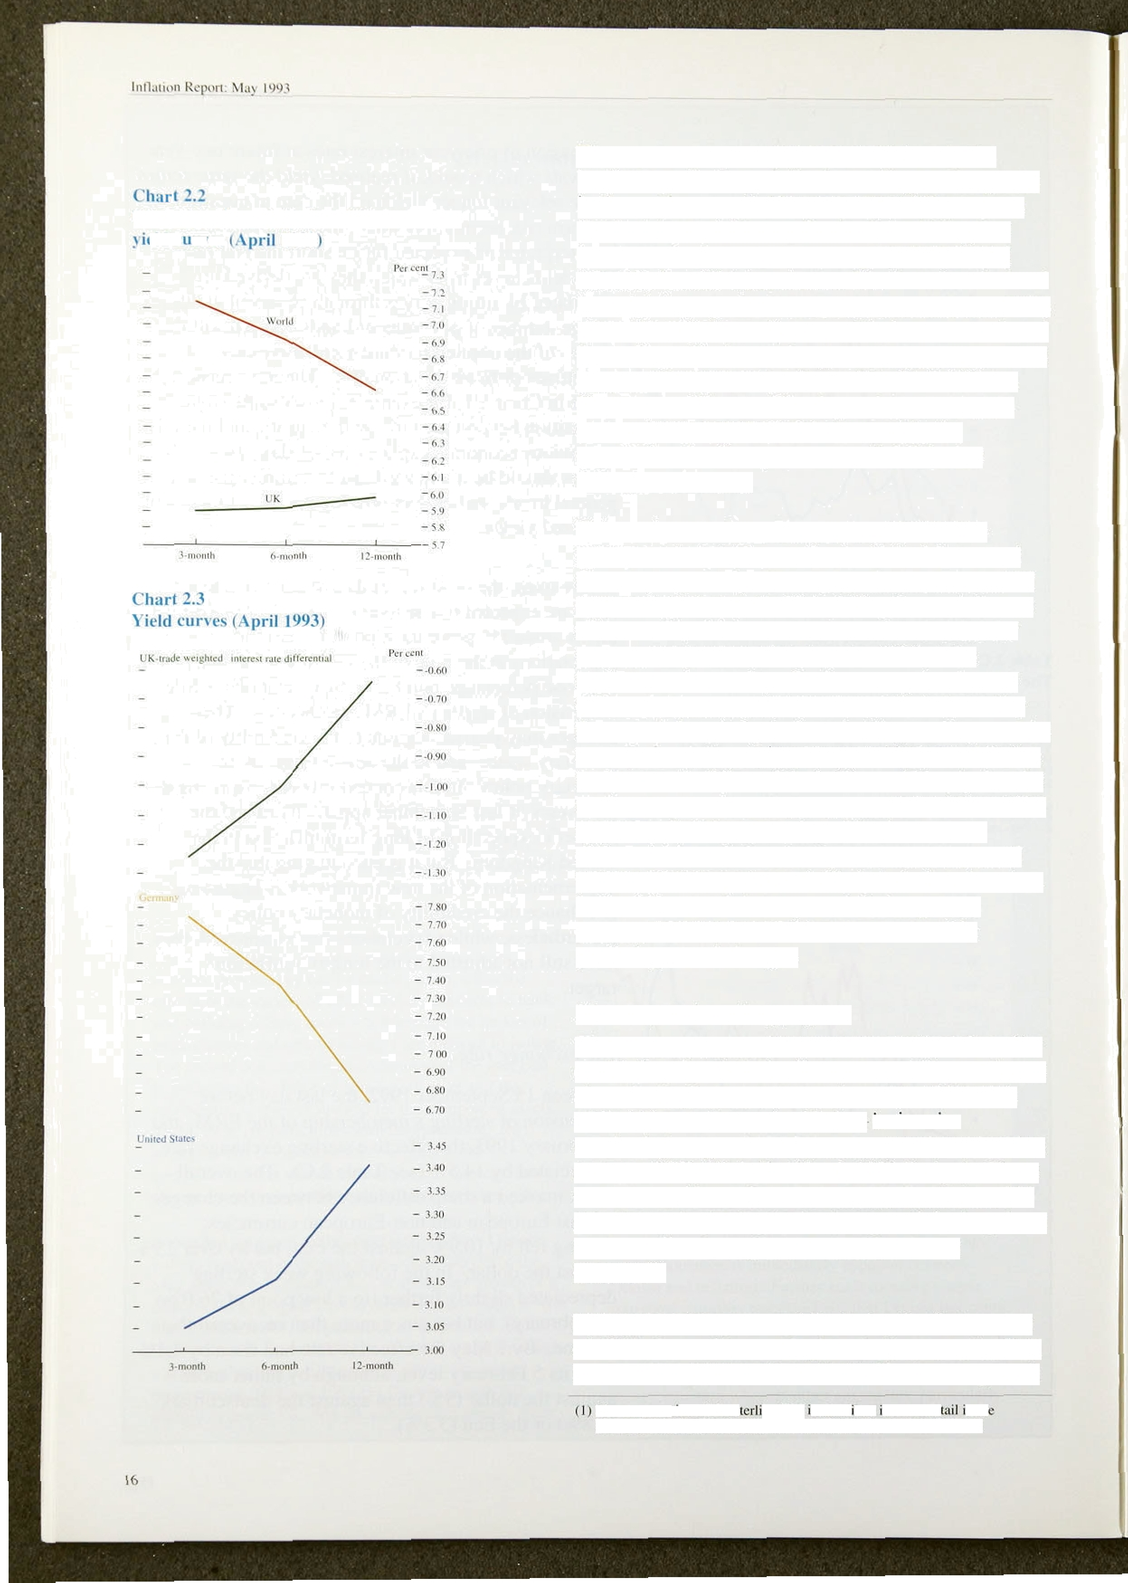

I l'i and trade-weighted u orld **interest rutc**

•ld c rx cs l0*J.3

The pattern of present and expected interest rates implies a particular path for the sterling exchange rate in the coming year and beyond. Chart 2.2 compares the short-term yield curve for the United Kingdom (over a twelve-month horizon) with a similar yield curve for ‘world’ interest rates. The latter is calculated by weighting together interest rates in sixteen countries where the weights are those used in the construction of the sterling effective exchange rate index (ERI).( The biggest contributions are those of the United States, Germany and France. The slope of the world yield curve is strongly influenced at present by the expectation that European rates will fall further throughout this year.

This can be seen from Chart 2.3 which plots the money-market yield curve for the United States and Germany separately, lt also plots the implied interest *clifferential* between the United Kingdom and the rest of the world, which narrows from around -! .2% for three-month interest rates, to only -0.6% at the twelve-month maturity. On the assumption that the differential in the interest rate is exactly balanced by

the expected capital gain from holding sterling over the same period (ie assuming uncovered interest parity), a twelve-month differential of - l % would imply that the markets expected sterling to appreciate by I % over the next year. But the narrowing of the interest rate differential is such that the expected appreciation of sterling over the next year is likely to be less than that. It should be noted that expected exchange rates calculated in this fashion have a poor record in predicting actual changes.

*M onetars' und t’redit aggregate.i*

The monetary and credit aggregates continued to offer conflicting signals in the first quarter. M0 growth rose above its target (now monitoring) range of 0%—4 , while M4 growth remained below its intenm monitoring range of 4%—8% (subsequently widened to a range of 3%—9% in the March 1993 Budget). There was some evidence from the monthly figures that M4 growth was beginning to rise, but growth in the private sector credit counterpart remained weak (see

Chart 2.4).

M0 continued to grow rapidly during the first quarter of 1993. Its twelve-month growth rate rose to 4.9& in March (from 2.8&• in December). Shorter-run growth

The conslfuttion of the s pg ERI s descr bed ri more de n th November 1988 edition of the *Bank ofEngland* 9rar/eriy *Bulletin.*



**.Chart 2.4**

**Twelxe-month growth rates of MO, M4 and the credit counterpart to M4**

- - 22



- 6



1990 91 92' 93



**Chart** M

Growth ratm of MO





rates have been rapid, with six-month and three-month annualised .growth rates of 7.loo and 9.5% respectively.

Growth slowed a little in April, although the twelve-month rate remained outside the monitoring

range, at 4.8&o—see Chart 2.5. Much, but not all, of the strength of M0 can be explained by faster growth of the value of retail sales, and the impact of lower interest rates (which lower the opportunity cost of holding cash). Other factors, such as changes in the composition of expenditure, may also be important.

M4 growth slowed further towards the end of last year. and M4 actually fell in January, when the twelve-month increase was only 3.1%—the lowest rate since the monthly series began in June 1983. The weakness of M4 was consistent with a number of other nominal indicators, reflecting the relatively flat profile for real demand and output, coupled with falling inflation. But in the past two months M4 has risen again, taking the three-month annualised growth rate to 5.3% in March. and the twelve-month rate to 3.6%. The main credit counterpart to M bank and building society sterling lending to the rest of the private sector—may, however, be a more timely indicator of future nominal demand because banks and building societies tend to act as liability managers, seeking to vary deposits according to the profitability .of lending opportunities. Credit rose by 0.49o in the first quarter, the smallest quarterly increase for over 25 years. In March credit actually fell by 0.2&o. As a result the twelve-month growth rate fell to 3.79r, from 4.l% in February.

Examination of the sectoral money and credit figures shows that borrowing was focused largely in the personal sector, but that the growth in deposits was more equally spread. Within the personal sector, net borrowing by individuals from banks and building societies was £1.9 billion. Borrowing amounted to fi4.6 billion, compared with £3.8 billion in 1992 Q4,

and is consistent with a recovery, albeit from a very low Jevel, in personal spending and the housing market.

Borrowing for house purchase increased by £4.2 billion (1.4&), up fi0.5 billion on the fourth quarter. Although

, recsnt reports in the press have .suggested stronger activity in the housing market, this has not yet fully

:filtered thmugh to the lending figures. This may be because enquiries. have not yet resulted in completions.

Coñsuinptio*o* borroWing increased 0.9&o in the first

##### :quarter, after 0.5,d (adjusted: for a loan transfer) in the:



**jnevious** quarter—consisteInt with. the rising trend in



retai[ sales seen over the quarter. Unincorporated businesses both reduced their bank and building society deposits and repaid debt during the first quarter. The repayment of debt, in the region Of TO.6 bill ion, was the largest repayment by

Unincorporated businesses since the series began. This may reflect continued financial restructuring.

Although their deposits increased by £2.0 billion in the first quarter, industrial and commercial companies (ICCS) repaid substantial volumes of debt. It is estimated that ICCs borrowed in January—perhaps reflecting the heavy corporate tax payments made that month—but that this was more than offset by repayments in February and March. This pattern may be the counterpart to the substantial public sector borrowing requirements in the latter two months,

which are likely to have boosted deposits and to have reduced the need for company borrowing, as well as assisting repayment of bank debts. Interpreting the behaviour of corporate bank borrowing is not straightforward, since companies also have access to other sources of finance. In the first quarter ICCs raised £2.6 billion from sterling capital issues.

### 2.2

Since the last

#### olic

*Report* the fiscal mea4ures

280

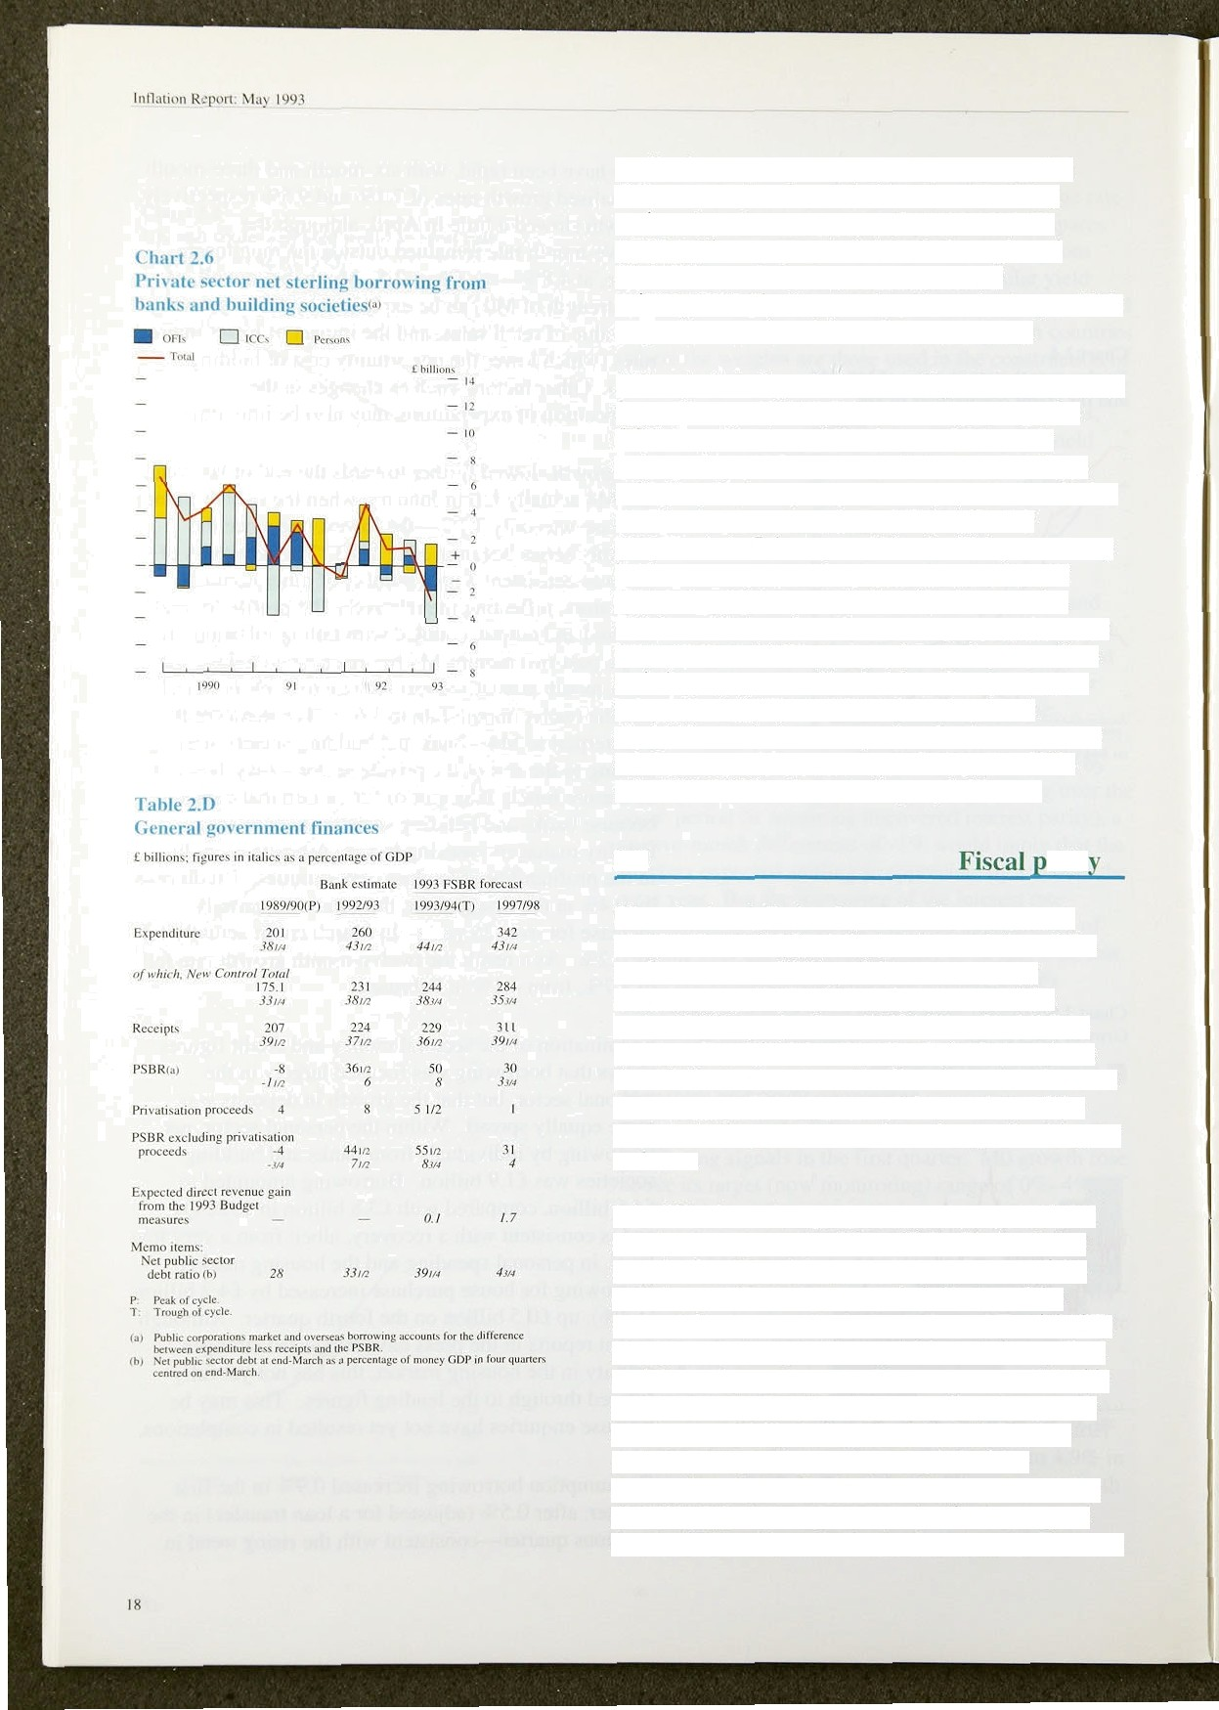

announced in the March Budget have reinforced the medium-term credibility of the new monetary framework. Although the announcement of the revised PSBR projection of fi50 billion for 1993/94 had the effect of raising long bond yields, they have since fallen back, as noted in the sub-section above on interest rates. This may reflect the reactions of the markets to the pre-announced tax changes for this year And next.

It is difficult to distinguish between the cyclical and structural components of the deficit. Their relative magnitudes depend, in particular, on the size of the output gap. However, one crude indicator of the structural component is the New Control Total (NCT) for government expenditure, which excludes cyclical social security payments and interest payments and is designed to capture discretionary policy changes. It has risen markedly during this recession. But the Autumn Statement measures, coupled with a resumption of growth, should reduce it substantially. As Table 2.D shows, government estimates suggest that **the NCT** will, on the basis of **average GDP** growth



of 2.file per annum over the next five years, decline to 35’t4 of GDP in 1997/98 from a peak of 38'/•% in the present fiscal year. This would still be higher *than i*ii the second half of the 1980s: the average between 1984f85 and 1989/90 was 34.6% of GDP. Government estimates *suggest that* ta *x* receipts will be

1.7 percentage points higher as a proportion of GDP in 1997f98 as a *direct* result of the tax changes announced in this year’s Budget. Although this change represents a tightening of the fiscal stance relative to l992f93, receipts are still likely to be lower in 1997/98 than in the late 1980s. Given that output was probably above trend in the late t980s, these comparisons suggest the planned fiscal tightening will reduce the structural deficit.

Even with substantial reductions in the deficit, however, the ratio ot net debt to GDP is expected to rise further. FSBR estimates suggest it may rise by over 16 percentage points between last fiscal year and 1997/98. This rise shows that large deficits not only create large financing requirements in the year they are incurred, but also leave a significant burden of financing for future generatiotls.



 

t’hari .3.1

**l3u nirstic output**



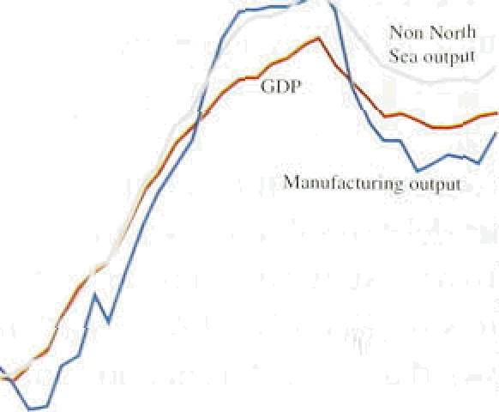

Chart 5.2

**Industrial** production

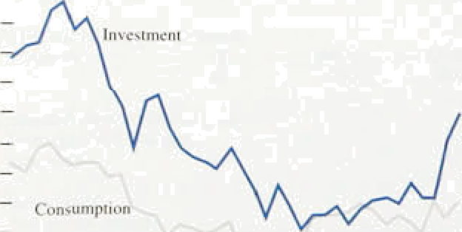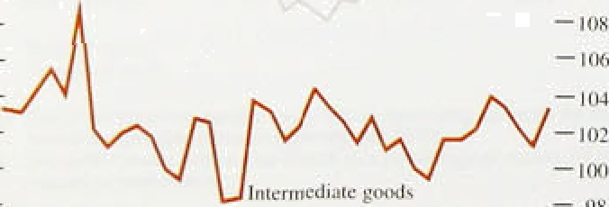

— 124

In the long run the rate of inflation is determined by monetary growth. But in the short run the speed at which inflation adjusts to 'the underlying rate implied by monetary policy depends on supply .and demand in goods markets. If output is high relative to 'normal’ output or ‘productive potential’ then inflation ,will, other things being equal, rise. And if potential output exceeds actual output there will be downward pressure on inflation. Short-run changes in the inflation rate reflect the size of this ‘output gap’. In this section we discuss the most recent.evidence on output, and hence the output gap, and on total demand which will influence short-run movements in total output.

Preliminary estimates suggest that **GDP** rose by around '/•9o in the first quarter of 1993, with non-oil output rising by more than '/•%. Domestic demand also appears to have risen in the first quarter, and survey data suggest that further increases in demand and output may be expected in the second quarter. Although the increases in output have been a little stronger than expected (especially in manufacturing) the gap between actual

and potential output remains sizeable, although it is difficult to measure with any precision.

## 1 Out t nd the o t t a

The preliminary estimate of GDP in the first quarter suggests that total output rose by 0.2& , the third successive quarterly increase in GDP. Excluding North Sea output, the rise is estimated at 0.6&o. to detailed sectoral disaggregation is yet available, but the monthly data on industrial output indicate that much of the recovery has been in manufactiiring„whére output rose by 1..2&o i.n the..three months to February over!tlie previous three months (see Cliart 3.1). grits iise-was the largest since February ,1992, and was broadly based.

Disaggregating industrial production **by class of** good, most of the. recent increase.has. come iti.:in?estment goods, with output up by 2.6T in the three fioiiths to

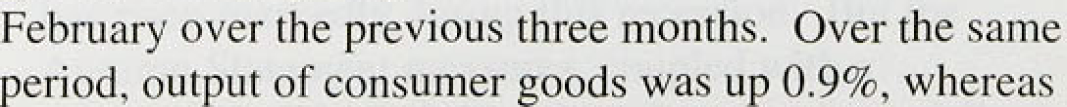

**output•of** intermediate **goods.fell** by, 0.9fi (see Cliart S.2). ’



**Chart!3fi Capacity:.utthcatioo**

' 90

The recent increase in output is unlikely to have been sufficiently rapid to narrow the output gap (the gap between actual output and the level of output consistent with a constant rate of inflation). But Chart 3.3 shows

- .BO







1979 8O 81 82 ’.83 B4 dS’R4. 87GB #9’’0O 91 92’9.3

**Cbart 3.4**

**Output.gap: deterministic trend measure**

**Chart 3.5**

**Output gap: production based approaches**



that the percentage of firms reported in the latest CBI

Survey as working below capacity fell from 73% in January to 63&a in April—the lowest figure since the beginning of 1991. The other CBI utilisation measures also suggest an increase in the rate of capacity utilisation, although it remains low by historical standards.

Statistical estimates of the size of the output gap vary widely. There are two main approaches to the measurement of 'potential’ output. The first identifies a trend in previous output growth and extrapolates it into the future. Such trends can be calculated in numerous ways. But they share a common implicit assumption that the trend in output is independent of other economic forces. Chan 3.4 shows the output gap implied by a simple deterministic trend with structural breaks. '›

The second method of measuring potential output attempts to take account of changes to productive capacity over the course of the cycle. Such measures are based on explicit ‘production functions’—relationships between output and inputs of labour, capital and raw materials—and their assessment of the output gap will depend on assumptions about the growth of both the capital stock and the labour force. Two measures based on such techniques are shown in Chart 3.5 which presents the OECD estimate of the output gap (based on an explicit production function) and a series which is based on estimates of capacity derived solely from changes in the capital stock. The two can be seen to vary widely in their assessment of the size of the gap not only at present, but also on many occasions in the past (including the previous recession), They also differ from the simple trend-based measure shown above.

The variation in the estimates of the gap in the past is important, for it will also lead to differences in the degree to which a given gap is.believed to influence inflation. An estimate of the size of the present gap is not, therefore; sufficient to enable conclusions to be drawn about the future path of inflation. This depends also.on the relationshi!p between the calculated output gap and.actual inflation. i.n the past. Although the

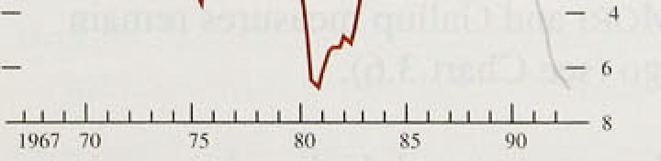





lIn1atit›n Rcpurt: Ma}' 19'?1



L?.x pundit ii rr cumpunents of' I: UP *1 c‹›nstu ii I prircs. Q4 1992



ch:rule



estimates of the current gap which.are generally quoted are in the range of 3% to 7 , it is not clear that such estimates are useful without the ad‹iitional piece of information about the impact of the measured gap on inflation in the past. But most models would be consistent with the view that the output gap remains sufficiently .large that it is continuing to exert downward pressure on inflation.

## 3.2 Demand

Domestic demand is estimated to have declined by around '/•% in the final quaner of last year, having

1 nx'estn fern





C’harl .3.ft

-0.8



-0.3

- I . I

rj.7



3:6

increased in each of .the previous five quarters. It nevertheless remained 0.4% above its level a year earlier (see Table 3.A). The fall was more than accounted for by a reduction in corporate expenditure: investment:fell by 0.8%, while faster destocking reduced .growth by almost '/29O. Consumers’ expenditure rose by 0.39•, the third successive quarterly increase. Public consumption also rose, by 0.29, but the most significant contribution came from the external sector, as imports fell by 1.l'7a while exports rose by 0.7%

Consumers’ expenditure increased in the fourth quarter despite a sharp fall in real personal disposable income (-0.89c). Real incomes remained 2.5& higher than a year earlier, although they were reduced by a combination of lower employment and reduced overtime working.



1 M 9I 92 93

_ zu

Latest indicators suggest that consumer demand grew sharply in the.first quarter. Comparing the three months to March with the previous three months, the volume of retail sales rose by 1.6&o, although the apparent weakness of sales in December last year contributed to this increase. Comparing .the latest .four months with the previous four, the increase was l.I fo. In the first quarter, sales were 3.39• above their level a year earlier. Further evidence of the strength lot consumer dismand 4s contained. in the 5ales of new cars (with registrauons up almost 12% in the year tolthe flit qiiaiter), as well as the increase in M0 and the growth:of consumer credit (see Section 2). Measured’of cohsumer, **confidence** have also continued the recovery .from their October trough, although both the MORI'and Gallup measiires remain lower,than. la year dgo (see Chart 3.,6).



per.sonal sector demand in thc past two yeurs, but this effect now seems to have diminished. Full s in interest rates have already had a marked effecl on income gearing (the ratio of interest payments to disposable income). Chart 3.7 shows that. for the personal sector as a whole, income gearing has dccl ined from a peak of

around 14% during !990 to an estimated level of only around IO.39r at the beginning of this year. This is still higher than at any time before 1959, but the reduction

' will have been sut’ficient to ease constraints on many

borrowers—especially younger borrowers whose propensity to consume may be relatively high.

A further constraint on consumption may have been the level of indebtedness. Capital gearing (ou tstanding lending as a proportion of net financial and tangible wealth) has continued to rise throughout the recession, as asset values (house prices) have fallen. At the same time it is likely that individuals have i educcd their

" -• ‹, desired levels of’ bon‘owing as they reassess their likel y lifetime income and wealth. But recent ev idence suggests that the housing market may be recovering.

" The Halifax house price index rose by *I .4Wc* in March

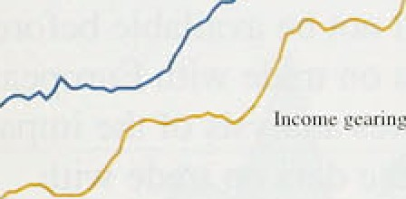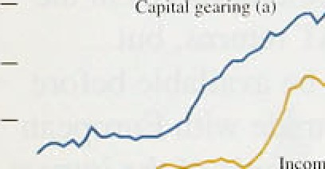

"""”""’

, and a further I.bin in April, more than offsetting the total fall recorded since last September. This rise in

' prices accords with the anecdotal evidence of increased

- " interest in the housing market since the new year. with

, the recovery in lending for house purchase, and with the recorded rise in turnover, as particulars delivered rose again in March (albeit from a very low base).

The recent Budget measure to double the stamp duty threshold on property purchases from £30,000 to



£60,000 is likely to assist the pick-up in activity, especially among first-time buyers. The Council of Mortgage Lenders estimate that only 239a of first-time buyers made property purchases of less than £30.000 in 1992, but 829c purchased properties for less than

£60,000.

|l The rise in house prices will have particular significance for those households whose mortgage debts are greater

than the value of the home on which they are secured. A note on negative equity was published in the August *Bank of England Quarterl y Bullefin.* Bank estimates of the scale of negative equity have risen reflecting turther falls in the Halifax house price index (unadjusted). The number of households with negative equity is thought to have risen to 1.8 million in the first quarter of this year. from 1.0 million in the second quarter of last year. The aggregate shortfall has also grown, to reach an estimated level of £11.7 billion, or £6,500 per household. The



extent of negative equity .is likely to have fallen .a little from these estimates, following the rise in house .prices irr April. If prices were to remain at their new level for the rest of the second quarter, the number of households with negative equity could fall below I ’/i million.

The precise estimates of numbers and value of negative equity are panicularly sensitive to the house price used in the calculation. The estirrtates also depend on a number of factors which are not well measured. These include possessions, which serve to reduce the estimates, and further advances and .mortgage arrears which serve to increase them. If these factors are ignored, then using the Department of the Environment index, which is available to the fourth quarter of last year, the number would be closer to 1.05 million, and the value to

£5.9 billion.

*Overseas trade*

With the completion of the EC single market at the end of 1992, data on trade flows with EC countries can no longer be obtained from Customs declarations as in the past. Data will now be based on VAT returns, but aggregate visible trade data will not be available before June 1993. The absence of data on trade with European Community countries complicates analysis of the impact of sterling’s depreciation. .But the ‹rata on trade with

non-EC countries suggest that the depreciation has resulted in a siiarp increase in the sterlingc prices of both imports and exports. Between August 1992 an‹i March 1993 non-oil import prices rose by 13% while non-oil export prices rose. by just under 10&o !i.mplying a slight fall i.n the terms of tra‹ie. The volumes of both exports and imports have: continued to grow sharply. Between August 1992 and March 1953, exports (excluding oil and erratics) rose by almost .129 while imports on the same basis rose by almost 11 %.

It seems probable that the.gro.wth i.n export v.o1umes to the EC has slowed in recent months, reflecting the general weakness of demand in Europe, and in Germany in p cular. Weakness in their home countries may also have encouraged European producers to.make greatér efforts.to penetrate the UK.market, especial!1y.given the growing. evidence of recovery in UK demand.. In.. add!ition, sterling's depreciation has‘been srñal.léi.lagainst the EC than.against.ithe,rest of.the world. .These.factors suggest that..the improvement.m!the.trade.position

##### **,vii-â-viJ** thñ’EC.may.be relativelJ/less than•tiiat.for other. countries,.. B!uf tire ‘J-CuiTe’ ’effect, whereby prices react faster to:exchange rate changes than do volumes, may

24:

Chart 3.8

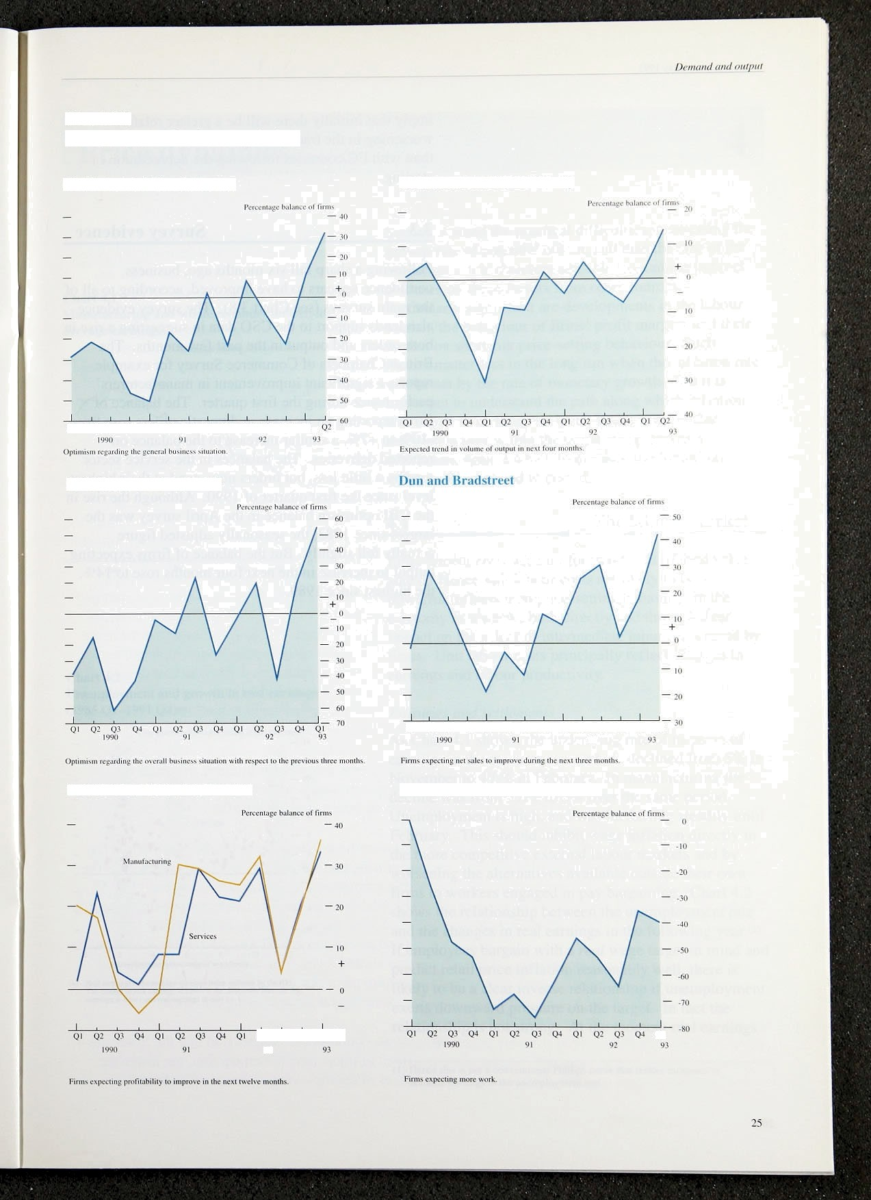

Survey data on business optimism

CBI Industrial Trends Survey

CBUCoopers and Lybrand

British Chamber* of Commerce Building employers’ confederation

Inflation ReptJñ: M_uy 1993 _

imply that initially there will.be a greater relative worsening in the trade position with non-EC countries than with EC countries following the depreciation of sterling.

3 Su e e en e

Following a sharp fall six months ago, business confidence appears to have improved, according to all of the main surveys (see Chan 3.8). The survey evidence also lends support to the **CSO** data in suggesting a rise in both orders and output in the .past few months. The British .Chambers of Commerce Survey for eKample reports a significant improvement in manufacturers' performance during the first quarter. The balance of firms reporting an increase in domestic orders rose from

-10% to +79o, a similar increase to the balance on reported deliveries. The balances in the service sector rose by a little less, but orders now stand at their highest level since the first quarter of 1990. Although the rise in the CBI optimism balance in the April survey was the largest since 1983, the.seasonally adjusted figure actually fell slightly. But the balance of firms expecting output to increase in the next four months rose to 14%, the highest since 1989.



Chsrt 4.1

**Manufacturing and** whole **economy** underlying

average earnings

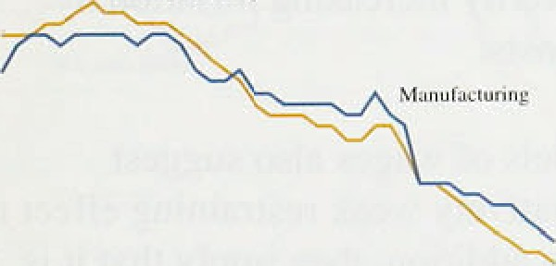

Section 3 noted the practical difficulties in assessing the growth rate.of potential output, and thus the size of the output gap. It is therefore sensible to examine indirect

evidence on these factors from other sources. Particularly significant are developments in the labour market, the behaviour of firms’ profit margins and their impact on short-run price-setting behaviour. Such

factors matter less in the long run when the inflation rate will be set by the rate of monetary growth. But it is important to understand the path along which inflation will adjust to its long-run level, both to ensure that inflation is kept within the target range, and as a benchmark against which to measure the 'news’ on inflation from period to period.

4.1 The labour market



Chart 4.2

**Unemployment anil growth in real earnings**

(1965 Q1—1991 Q4)t



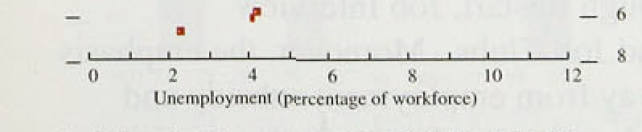

EmP yment costs account for two thirds of total value

.added. Hence unit labour costs are likely to be a

powerful influence on price-setting behaviour in the economy as a whole, both directly and through their impact on the prices of intermediate inputs purchased by firms. Unit labour costs principally renect changes in earnings and labour productivity.

*Eariiin,gs and settlements*

.As Chart 4.1 shows, the underlying rate of increase of earnings in the economy as a whole declined from 5% in November to 4'/ % .in February. In manufacturing the decline was from 5’/4% to 5& over the same period.

Unemployment is high, and was increasing steadily until February. ThiS should inhibit wage inflation directly in the: more competitive external labour markets and by worsening the alternatives available outside their own firms to workers engaged in pay bargaining. Chart 4.2 shows the relationship between the unemployment rate arid the changes in real earnings in the following year.( ) If employees bargain with a reaf wage target in mind and predict retail price inflation reasonably well, there is likely to be a clear inverse relationship if unemployment ’exerts downward pressure1,on the target. In .fact the relationship is not strong. At the moment real earnings









ther i3

l'ncnp{O Inent aDd r*al stttzn3*I3N usiMg





I988 ] y

.0

are still increasing quite rapidly; learnings.deflated! by the Tax and Prices Index rose by. 3.69• in .the year to February 1993, despite .the.fact that the ,u!nemployment rate was 9.4&r in February 1992, and rose. to 10.6.&o a year later.

There is more sign of an inverse relationship if unemployment rates are compared with the real earnlngs increases expected by trades union leaders when pay settlements are concluded. Chart:4.3 shows this rising polling data on expectations and IRS data on settlements. Thfs illusuates the problem which arises if wage bargainers do.not regard the inflation target as credible; nominal wages will be set too high, reducing

I gg0 i 989

— 0.¥

- Li.6

0.4

###### employment and temporarily increasing inflanon by increasing unit labour costs.



7 9

No\c. Oates dler io the fin gunner in cach ycur.

Tahle 4.A

Line or t›cst lii



— 0.8

Many econometric models of wages .also suggest unemployment has a relatively weak restraining effect in the United Kingdom. In addition, they imply that it is the deviation of the unemployment rate from some equilibrium rate rather than the rate itself which leads to rises or falls in wage inflation. Unfortunately, estimates of the unemployment rate consistent with stable in(lation (the ‘NmRU } differ widely. A recent paper identified a large number of studies which had attempted to evaluate the NAIRU in the United Kingdom over the past twenty-five years. Table 4.A shows that the range of estimates varies consilderably both within and across decades. There is, therefore„a considerable degree of uncertainty about what will happen to nominal wage, growth when the end of rapid reductions in retail price inflation starts to affect wage bargaining.,

There. are some grounds for tliiñking that hi8h

N.4jKL **estimates for the** United **Kingdom**

**‹claimant** definition)’“›

Period within which inc csumates-fall

f 969-73 l_97M0 1981 —87 1988-90

Actual U rale 2i5W 3.8& IO.IN 6.8& n.climates i i 13 15 5'

f*j R Cromb. ’A survey *f reccai ctpnanieiric » nd: on. £he FiAfRU’, dnviwiif



: 28.

unemployment levels will continue to exert downwarci, pressure Ion nominal wage growth:

P



Government labour market policy has lfocuse0 on

ed rema:in acti.ve.in.!th.e





JexeJ ñf **u'niinip1oyment consistent** with stable



**Whole economy. wage settlerttents and earnings‹•**





fa) Dat* rsiigcs arc' dciermincd by âvai lsbitiiy of •iilcments.'ilata.

inflation. Trades union membership (based on data from the Certification Officer) fell considerably over the 1980s, from 579 of employees in 1979 to *44%* in 1990.

###### The composition of the unemployed is different from.that in the early 1980s: more come from skilled and professional occupations; they may be looking for jobs more actively because their financial loss due to unemployment is greater.

The fall .in pay settlements over the last three months has been more pronounced than the fall in earnings growth. Settlements are often treated as a leading indicator of earnings growth, although, in practice, turning points in settlement rates have tended to coincide with turning points in the growth of earnings. The Industrial Relations Services measure of whole economy settlements fell from 3.6&o in the three .months to December to 2.9% in the three months to March (see Chart 4.4). In manufacturing, according to the CBI, settlements fell to 2.5% in 1993 Q1 (eKcluding companies freezing pay for up to six months), which compares with 2.9% in 1992 Q4. Service sector wage increases continue to exceed those in manufacturing

.industry. The CBI Pay Databank Survey shows private service sector pay awards averaging 2.8& in 1993 Q1. In November 1992, the Government announced funding arrangements for public pay predicated on public sector pay increases in 1993 falling between 0% and l.5&o.

*Labour proc:Iuctiviiy*



###### The annual rate of growth of productivity in the whole economy .has continued to rise, reaching 3.29o in

1992 Q4 (see Chart 4.5). In manufacturing industry productivity was on average 5.9& higher in 1992 Q4 than in the same period a year earlier. Monthly figures show no sign of a slowdown: the twelve-month rise to



.February 1993 in productivity in manufacturing was 7.8% the same as in January, but higher than December (6.29b) and November (5.5%).

During the‘early stages of this.recession firms did not hoard labour to„the same extent as during the previous. two downturns. The rate pf.labour shedding increased in the. eecond half of 1992. As .Chart 4.5 i dicates, it is .not unPr«..ederiled..for Gqcfi. roducfivitx growth to occur:in

###### ' “"“’'! ' " the recovery phase.. But.there’is probably less ñour

"” ’! '" “ ‘” ' ' **Jo&diitg** IN unw;ndthis time, #o employeiqnt growth







L'‹›ntrihutioi r **uf earnings antJ pr‹+ductivi(i t‹›**





|  |  |  |  |  |  |
| --- | --- | --- | --- | --- | --- |
| F<n‹xl | £Jtitptil | Einpl‹›yn›ent | LJhaur | Earnings | Unii |
|  |  |  | produ«ttviI} | per | w4yc |





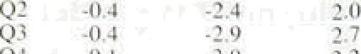6,5 4.4.





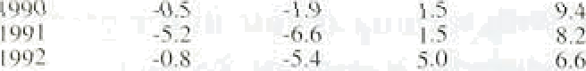



N3 0.7 -4.7 41 6.? l.O Q4 C4 52 . vO v7 02

Charl 4.f+

Rvlail **yrices** tlnd unit ›s-uge cnsts

lYholc economic 



2



fl



”kahle 4.t

**Manufacturers* input prior infIation‹•›**



Matcrinlst bl Fueltbi Totaitbj All miinutac,turing

may pick up sooner, particularly if the costs of employment adjustment.are now less. The falls in unemployment in February and March, the mtich smaller fall in the workforce in employment in 1992 Q4 (91,000 compared with 398,000 in 1992 Q3) and, in February 1993, the smallest monthly .fall in manufacturing employment since the first half of last year, all support this conclusion.



Table 4.B tabulates the contributions of earni:ngsS, ou.tP

###### and employment growth to increases 1in unit wage costs.

Whole economy unit wage cost growth declined to 1.9% in the year to 1992 Q4, down from 3.0% in the year to the third quarter and 5,3&o in the year to 1991 .Q4. The growth rate has fallen below RPIX inflation since early 1992, which should help to contain.inflation in the near future. In manufacturing, unit wage costs declined by

0.79 over the twelve months to December 1992 and by 2.6% in the twelve months to February 1993.

4 2 I t t

It is important 1to examine other in



###### businesses. The CSO compiles an input price series for manufacturing industries which ineludes the cost of raw materials and fuels, .but not, unfonunately, bought-in services. Table 4.C shows recent trends in input price inflation for manufacturers, and illustrates that the costs

.of these inputs .fell in 1990 and 1991, and through„much. of 1992. Price declines were particularly. common for material purchases, although increases in fuel costs (which comprise around ñ9• of the total input price index) have been modest..

Almost half of the net inputs to manufacturing industry are imported, so the depreciation of sterliing since September has,resu1ted in an increase.in.input prices.. Not all inputs, are impo’ned however, and doinestic demaqd conditions are likely to hav,e plate:d downward. pressure.:on the.price of those inputs!.sourced.

.domesacally..

**jggg**

t99{



-I.’7 2.7 -0.9 -0.2

.3:3 I:5 -2.2 -I.2:

-I.d 2.6 -0.7 0.S



Q3 ’-t4 3’.2

Q4 '3.3 4.6':



6.5

7.0

**4.3 Business margins and,the:retuJ**





###### The profitability of the existing capi!tal stock is a gujde to’nte pressures on prqduuw tn alter pri and costs as

30



*Price d mice*

**Chart 4.7**



well as invest in new capacity.( ) Pre-tax profit rates- profits divided by the net capital stock valued at current replacement cost have fallen in this recession, but they remain relatively buoyant in comparison with previous

’ 2 downturns. More recently, it appears that the decline in

— pre-taK profit rates has slowed, with the all-ICCs measure averaging 7.49c in 1992, compared with 7.99c in **1991** (Chart 4.7).



_ _ Measures of total profits divided by total costs can be calculated for both the whole economy and the non

— 2 2 * **North** Sea economy (Chart 4.8). After increasing in the

„ "„,p„,q,pp„q, „„ p,p„p„„,q„ „„ qp" second and third.quarters of 1992, the ratio for the non

coii, with e4josiinentvfar ilie iinpact of iiifiaiiun orrsiock oppreciutioii









North Sea sector fell by 4.4 percentage points in the fourth quarter, because of rising costs and falling profits. This ratio is now higher than in both the mid-1970s and the early 1980s, so the pressure to restore margins as the economy.recovers is unlikely to give rise to substantial inflationary pressure, although a short-run effect is to be expected.

"° Another way to assess profitability is to compare



go rrlovements in producer output prices (excluding food, drink and tobacco industries) with weighted movements

'" in manufacturers’ costs (Table 4.D). This also indicates

_ „ that, given the length of the recession, profit margins have held up relatively well in recent years. In the

1070 72. 74 76 7#’’’ 80 82 ’84 86 ’88 '70 ’B2 — initial stages of the downturn, falling input prices

ensured that the increase in unit labour costs did not

###### yqq 4• p cause producers to pare their margins in the face of

c«»t s»u»nr•i to manufacturers.’ output p i•• increased competition.

###### "" ,p, The evidence on profitability, mark-ups, and

% comparisons of input and output prices suggests that profitability has been maintained during .the recent



., , recession. The effect of the sterling depreciation on profit margins depends on how input and output prices



‹ ‹ will be affected by the lower exchange rate. In turn, this

7.:Outpmp%oset. 4’.9

2.' 2 '' "' 2 4 '’’ 2'6 depeiids on the extent to which the goods making up

.these indices are homogeneous and traded in internationally competitive markets. Although there appears to be a relatively close correlation between movements.in the exchange rate and input prices, output



«

'(4)..Liofoitunaieiy,.precin:data.'on tire capital siock are. difficult:to obtain. ..Tbe **méasures.** ..:.use:data provided **by.the** CSO on the ne capital stock **of ICCs** value4 at r•pla°ement.cost-. Th.e:measures may noteapiure rally.the extet or



,'f& iétl:'.AUC lk. 'A6. .donl.,j'-flft111lal eStimfit08. ale.:pmvi.fi0d,.q rly.observatiñns





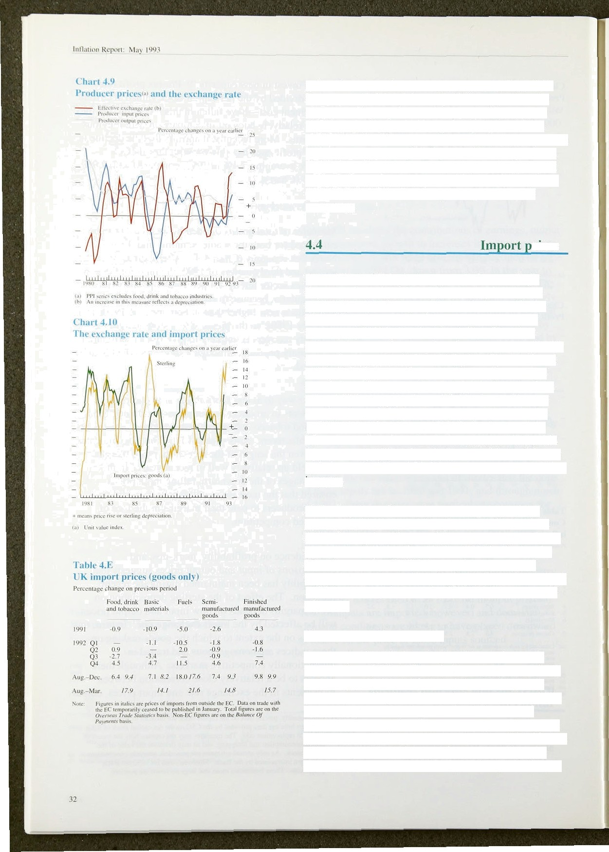prices show a much more stable trend (see Chart 4.9). Data for 1992 Q4 and for early 1993 suggest that the response of input prices to the depreciation has been significantly greater than that of output prices. One explanation for this output price ‘stickiness’ could be the heterogeneous nature of many manufactured products, which may nllow producers the scope to delay passing on the impact of exchange rate changes until they have established whether the changes are permanent or temporary.

## rices

Import prices fell in the two years before sterling’s departure from the ERM. This resulted from lower growth in competitor countries, weak demand in the United Kingdom and the delayed impact of earlier sterling appreciation against the dollar. Since last autumn, however, import prices for all main commodity categories have risen substantially (see Chart 4.10 and Table 4.E). Between August and December, the last month for which data on imports from all destinations are available, import prices of finished manufactures rose by almost 109 (within which car prices rose by 14%) compared with around 7% for basic materials.

More recent data show that in the seven months to this March import prices of goods from outside the EC rose by between 14.1 to and 21.69 for all major categories of imports.

Reflecting the earlier weakness of import prices of materials, which account for almost two thirds of the index, input prices for materials and fuels purchased by manufacturers fell during 1990 and 199 l. During the first nine months of 1992, input prices (seasonally adjusted) were broadly flat. In the eight months to April 1993, however, prices rose by 10.1% (7.2&o seasonally adjusted).

*Meo,iuremeiit of iriipoi‘t yr i‹es*

Where available, the import price data used are unit value indices (UVIs). These indices are base weighted. However, since the weights are determined by trade patterns prevailing in earlier periods, the data shpuld be treated with some caution. An alternative way of measuring import prices is to use average value indices (AVIs). This method produces a current weighted index. If the composition of imports changes over time, the AVI and UVI measures are likely to diverge. In fact, as



f'eroentage!changes:on the-previous quarter '



shown in Chart 4.11, the growth in the two measures has in the.past been quite similar, [) During 1992 Q4, ilTipoFt prices of total goods rose by 8.2Ra on the AVI measure com:pared with 9.1&r using the UV.I.

1992

Q1 1.9. 0:3

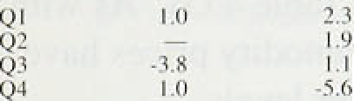Q2 1.0 6.3

s›

- I.O *S.0*

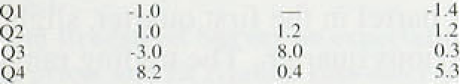— *-S A*

-2.3

- l.3.

1.6

2.0

'l .2

-1.7

*Commodity prices*

About 42% of imports are used as inputs rather than for satisfying final demand. Most imports of raw materials fall into the former category. This is one avenue through which inflation elsewhere in the world can be imported to the United Kingdom, unless the exchange



Chart 4.11

Import price5-••a{) goodc

 



Table 4.G

Commodities prices breakdown



Ql 'Q2 Q3 Q$ Q1





*

The Economist All-Items index of non-oil commodity prices measured in SDRs rose by 7.2&o in the first quarter of the year, compared with the previous quarter. The largest price increases in the first quarter of the year were in agricultural products excluding foodstuffs, and most notably in timber which rose by more than 309c.

Timber prices were particularly affected by restrictions on supply related to environmental concerns, but the rise in commodity prices has been quite widespread. Cotton prices rose significantly. Food prices, notably sugar, rose further after the increase in the fourth quarter. But during the.second quarter, commodity prices have fallen back somewhat.

Commodity prices have risen despite the low level of activity in the major economies, even after allowing for special supply factors. Output in the major six economies is growing at an annual rate of about 1'/ %, and its level is significantly below trend. The recovery in North America, and more recently in the United Kingdom, may exert an impact on certain commodity prices but it is unlikely that this alone accounts for their buoyancy in the first quarter.

The Economist All-Items index uses weights based on the values of commodity imports to all OECD countries in 1984—86.(2) UK impor@, however, contain a higher

###### ricultural products than these



weights suggest. This means that commodity price

8er impact on the United Ki!ngdom than the OECD-based Economist All-Items index would indicate: UK-weighted non-oil





InfIaIi‹›n Rep‹›rt: May I ' g3 _



— 10*

commodity prices rose by over 20&o in the first quarter, following a rise of around 17 r in .the fourth quarter.

The marked rise in the UK index.in the first quarter reflects the timing of the large increase in non-food agricultural product prices (see Table 4.G). As with the Economist index, however, commodity .prices have fallen back from their last quaner levels.





**t’hart 4.13**

**Sterling and dollar** oil **prices'** 'i

* The price of oil. as measured by close-dated Brent

###### •‹› crude, was $18.3 per ñarrel in the first quarter. slightly

„ lower than in the previous quarter.. The trading range for oil prices was comparatively stable in the first quarter.

###### The February OPEC meeting agreed a cut in production ” for the second quarter of the year but the markets remain

sceptical that this will be fully achieved. There is little prospect that Iraqi exports will resume in the.short.term, but even without this the market seems set to continue to be well supplied. Sterling oil prices fell by 0.79c in the

"' first quarter, after rising substantially in the fourth, so

„„ further cost pressufes from this source are likely to be muted.





**Chart 5.1**

**Dun and Bro4streei Surrey on expectations of selling prices and EC/Gallup consumer inflation expectations**

The outlook for inflation depends on both the starting point (discussed in Section 1), and the interaction between monetary policy (Section 2) and the state of the real economy which determines the speed with which inflation adjusts to its long-run rate (Sections 3 and 4). This section analyses the prospects for inflation. It presents information on private sector expectations of



1 2 momhs std ts1

* + inflation derived both from direct surveys arid
  + independent forecasts, and indirect inferences from the

^ yields of government securities. The section concludes

< with Bank projections for inflation over the next two

— › years based on the analysis presented above. An

,› essential element in this is a comparison between the

, projections in the February *Reyort* and both the current

+



- 0

— 10



###### projections and the actual outturn for inflation over the past three months. Differences between the earlier and current projections reflect the ’news’ that has emerged since the February *Report.*

5 1 S rve s of i fla on e e ns

.Survey evidence suggests that, on balance, expectations of future inflation are higher now than before suspension of sterling’s ERM membership. The April *CBI InduSfrial Trends Survey* showed a balance of 10% of respondents

Cp s 2 expecting a rise in domestic output prices over the next

**GAllpp 8urvey of** employees’ **price ex** ti»‹.› four months, compared with l 1% in January and -37c

.last October. Even allowing for the normal seasonal increase at this time of year, price expectations are still higher than six months ago. The *Dun and Bradstreet Survey* .on expectations of selling prices paints a similar picture. The balance .of respondents still expect prices in the following three months to be lower than a year earlier, but the balance is much less than in the previous

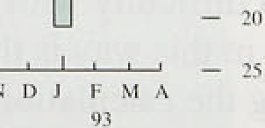.two quarters (see Chart 5.1). The *EC/Gallup* 5itrvey of consumer inflation expectations also indicates diminishing disinflationary pressures. In March and April one-year ahead inflation expectations were at their highest since June .1991—although still low by historical

 standards (see Chart 5.1).

'’ . *Galtup* also.publishes.a!.more detailed monthly su: rvey of 'waye aitd.price:iexpeciations,.in which. around 1,000 emplny are asked what percentage increase in prices

 tkey pect over!the.next twelve:months. Chart 5.2

3S



shows the balance of respondents expecting inflation to exceed 4 over the relevant period. The.survey suggests that the proportion of employees expecting inflation to remain within the target range exceeds the proportion. expecting inflation to exceed the top!of the range by l 2%a.

The *Barcluys/NOP Survey* of the general public in March also indicates that expectations of inflation

one-year ahead are just above 4&o. The two-year ahead expectation is rather higher, at 5 o. By contrast, the *Smith New CourUGallup Suwey* of fund managers suggests a gradual reduction in year-end **RPI** .inflation expectations for both 1993 and 1994. In October of last year respondents expected inflation of 49a by December 1993. But since last autumn expectations have been revised downward possibly reflecting better than expected inflation outturns—and now stand at just over 39c. The latest surveys also include an expectation for end-1994, which is now 49r.

# Evidence from financial markets:

**‘Break-even’ inflation rates**

A potentially more accurate source of information about expectations of future inflation comes from a comparison of yields on index-linked gilts (IGs) and conventional gilts. Such ‘break-even’ inflation rates are calculated by subtracting the yield on index-linked bonds from the yield on conventional gilts of similar maturity. In practice, the assumption that index-linked gilts are independent of.inflation is unlikely to be valid. In the first place, index-linked gilts are not perfectly indexed: coupon payments are indexed only up to eight months before they are made, so that inflation in the intervenIng period can erode the value of the .stock.

Second, if a risk premium attaches to:either category of bond (and the.risk premium may be related to a number

.of uncertainties, including that.surrounding future inflation) then the break-even rate will riot measure expected inflation alone, but will.a’lso incorporate the difference in the .respective risk:!premia,

One.final practical difficulty with the calculation of expected inflation in.this way is the treatment of taxation. Adapting the calculation.to take account of taxation is straightforward enough, but the assumption ’regarding the.rate.of.tait !paid by the mnrginnl iaxpay9r has a,eignificant impact,on tiielevet ñf the bneak-even rate: Chart15.3 shows that break-even rates!can vary by

##### over three.percentage p.oirtts at present; depending or!the.

**Chart SJ**

**Break-even inflation ratcs•›**

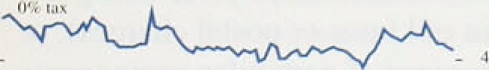

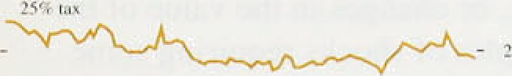

fen.   Apr. May



**Chart S.J.**

**Nominal and real implied forward ratm**



.tax assumption. .Such wide variation, when coupled with the other problems associated with the calculation of these rates, creates difficulties with the use of such calculations.as estimates of future inflation.

Ignoring the problems of risk premia, and assuming that the marginal rate of tax paid by the marginal investor is zero (which is consistent with that investor being a pension fund, for example), it is possible to derive a continuous profile for the term structure of inflation.

Section 2 above discussed the calculation of implied forward interest rates from the yield curve for conventional gilt-edged securities. In an analogous fashion it is possible to derive a continuous term structure of real returns on index-linked gilts (see

Chart 5.4). The difference between the nominal and real implied forward rates provides a measure of the expected rate of inflation at any point over the next twenty-five years. The resulting inflation profile is shown in Chart 5.5. This indicates that inflation is expected to rise from just over 49c in two years time to an average rate of a little over 5&o from around six years onwards.

* 1. Outside forecasts

 



2

12 l4 16' 18 ' 20 22 24

**Chart 5.5**

Charts 5.6 and 5.7 show the latest projections of RPIX

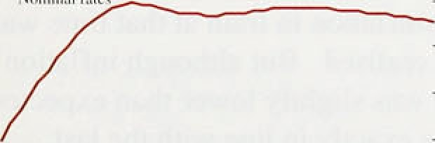.inflation from 36 independent forecasters, including City firms, academic institutions and other private sector organisations. Comparing these forecasts with those at the time of publication of the previous *Report* it is clear that the variance of the distribution of forecasts for inflation.at the end of this year is now less than before, and that the median has fallen slightly, to 3.6 o. The variance of the distribution of the end-1994 forecasts is

Inflation expectations‹•›

- ’7.0

also lower. Both the median and the mode of the distribution are .around 4&o. Of the 36 forecasters, 18 expect inflation to be at or below 4&o by the end of next year, whereas in February this view was shared by only 12 forecasters.



-: ’” .4 ”.



*Thé short-run outlook*

As in the Feiiiuary fn/Iotio›t *Report,* projections of

**in;Ration over short** and **longer-term** horizons are

 



” 37'



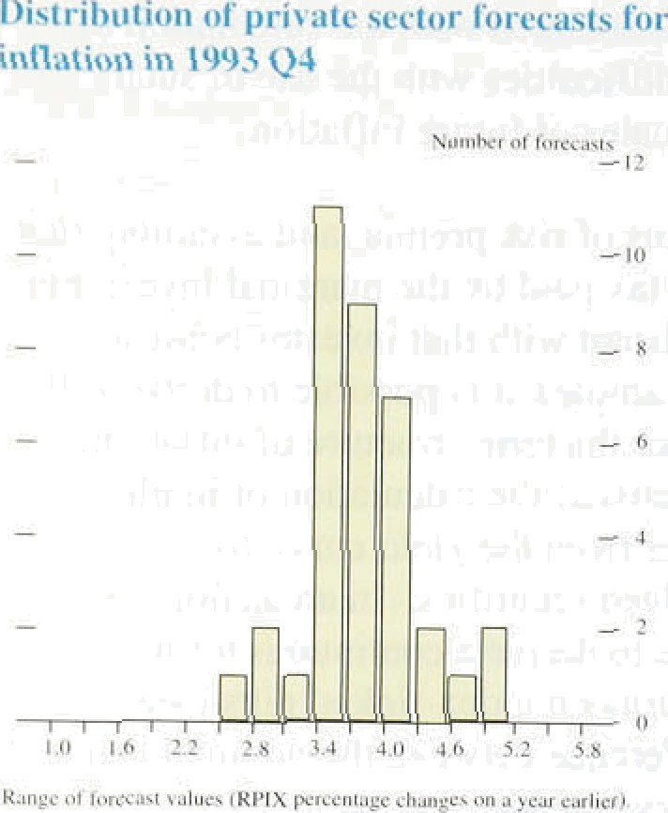the projections of int lation are based on statistical extrapolation of recent trends in a number.of components of the RH. These extrapol‹itions are modified to ref'lect known administered pricle changes (for example, changes in rail fares oi postal charges), or’ where the short-run behaviour of particular components is thought likely to respond to .some external shock

which is not ali’eady embodied in its paS1 behaviour. The depreciation of sterling. or changes in the value of the green pound, are examples of shocks requiring sc›me modi.fication to the short-run extrapolation.

Chart 5.S pi e.sents *the* latest projections for RPIX inflation over the next three months. and .also shows the. projections mode at the time of the last *Re Port,* together with the recent outturns. The difference between projection and outturn may simply be the result .of errors in the modelling of short-ru» inflation, but where errors become large and persistent i.t may be that the divergence represents ’.news about inflation which constitutes information relevant to po.licy. Thus last autumn the outtui us for inflation were significantly— and persistently—lower than had been predicted, suggesting that the disinflation in trai.n. at .that time was greater than had bgen real.ised. B.ut although inflation in January and February was,slightly lo.wer than expected, the March outturn was exactly in line with the .last forecast. There .has been little news fiontaine‹l in the inflation figure.s published since the last *Reyort.*

The projections for the next three months show inflation declining .in .April,. but them rising to 3.5% by .June. The initial. .fall largely reflects ,the imp3ét!of the. Strange...firom the Communi.ty Charge to the Council. Tax. The subsequent risle is expecteci to be broadly based and .is associated with the direct.pass-through pfi highrr import

 prices .into domestic retail prices.

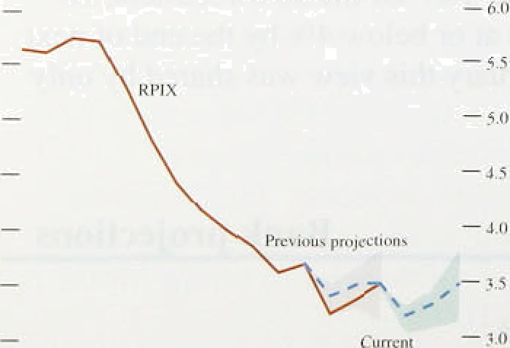



Vector autoregressive (VAR) models of inflation use historical relationships, between inflation and a set of other variables to .predict inflation: in.!the future. Such mo‹iels are. described ’in. more detail in ttte article on. pages 231 —9 .of the M3y *Quarterly B!ulletin.* Research in tire.Bank suggests that variañlestwhirh are useful (n predicting!the month1!y profile.of:.inflation include M0, producer output prices; retai.l sales and.the outpu’t o.fi the production industries. The quarteTly profile of inflation is..:predicte d 0y usi:rig M0 anfi the EC/Galle:p index of consumer confidence.

It is important to understand the way in which these variables were chosen. Although it is possible to estimate VAR models which have a structural interpretation (that is. which can be interpreted in terms of a plausible.economic model), the models used here were selected solely on the basis of their ability to track

.inflation.

The latest forecasts from the two preferred VAR models are broadly consistent in suggesting that inflation may begin to rise during the course of 1994. But their projections for 1993 conflict, with the monthly model offering a central estimate of RPIX inflation rising above the target range in May. This is also at odds with the extrapolative model, the projections from which are likely to be more soundly based in the short-run reflecting the known adjustments it incorporates, and the more detailed examination of the components of inflation which is undertaken in that approach. The size of the standard errors on the VAR forecasts should also be noted. Although the central estimate from the monthly VAR model is slightly over 4&o this year, a 95% confi‹ience interval around this estimate would embrace any rate of inflation between 1% and 7%.

VAR models can be useful additions to the range of techniques available for analysing current and prospective developments. Where the models are unanimous in their projections it is likely to be easier to draw robust conclusions. But where models conflict the projections derived from structural models become increasingly important.

*Longer-term structural projections*

In the absence of major shocks, projections for inflation over a two-year horizon are unlikely to change substantially within a three-month period. But new information can be grouped into three categories:

fl. The outtum for inflation compared with expectations. As noted above, the outturns for twelve-month RPIX inflation were a little lower than .expected in January and February, but exactly

: as predicted in March,

0 The outturn for the other factors which determine the RPIX **projections** compared with expectations. This includes changes to the exchange rate and other xariab.les; such as.asset prices, labour rñarket conditions and.out;iut data, which contain some





short-run information on the likely outturn for inflation.

0 The announcement of future measures which are likely to have some effect on prices. The increases in .indirect taxes announced in the March Budget, including the extension .of VAT to domestic fuel and power, are an example.

The first of these factors shows that there has been little ‘news' in the outtum for inflation itself. But the second set of factors contains several pieces of information which lead to a revision of the projections. The most important of these is the 5% rise in the exchange rate since the February *Report.* If the exchange rate were assumed to remain unchanged at an effective index of 81 (compared with 77.2 at the time of the .February *Report ),* inflation would be expected to be about one percentage point lower both this year.and next. Among other indicators, wages have risen less than expected eading to a slight downward revision to expected inflation— while the increase in output, whi:ch has been greater than expected, acts in the opposite direction.

**Chari 5.9**

**RPI** X **infiaiion** projections and outturns







The third factor is the impact pf the eKtension of VAT announced in the Budget. The 8% VAT rate for domestic fuel and power is likely to add around 0.4% to the headline RPI from April 1994.

Taking all of these factors to,gether, the central projection for **RPIX** inflation .is shown in Chart 5.9. Inflation is likely to fall during the remainder of this year, as the impact of the earlier depreciation is partly offset by the subsequent recovery in sterling, and the disinflationary impact of the output gap persists. But as recovery gathers pace this disinflationary effect will diminish, At the same time, headline RPI inflation is likely to, rise around the turn of the year as interest rate cuts drop out of the twelve-month comparisons, and the reduction in MIRAS will add a further '/‹ percentage point to the headline rate in the second quarter of next year. These may feed in.to. the rate!.at which wage settlements.'and:eamings rise. Nevertheless, ‘underlying’ **inflation *(RPIX*** inflatioh *deluding We* impact.of the VAT extension) will probab1y!!remain broadly flat during 1954, at j,ust.over 3.&,. **Allowing** for the VAT extensipn, however, RPIX:inflation is hYely to rise front **the second quarter of nert year** though.bit is still likely to Britain within tkp .target **range.** ’

On balance, the changes since the last /fl often *Report* have lowered slightly both the expected inflation rate and the probability of breaching the 4D Jimit during the course of this year. The impact next year *of* the Budget measures. together with the uncertainties surrounding the rate at which the output gap is likely to narrow, suggest that the probability of breaching the target next year may be a little greater than previously envisaged. but the Bank’s central expectation still is that the target will be *met.* Any further increase td#crease) in the exchange rate would lower (raise) the probability of breaching the target.

 

Inflation, as measured by **RPIX.** has remained within the target range throughout the period since the February *Report.* During that period new information about the likely course of future inflation has been of three main kinds. First, real activity is rising .more rapidly than had been expected three months ago. Most of the indicators relating to the real economy, including output, retail sales and employment, point to increasing levels of activity.

Second, the exchange rate, as measured by the sterling effective exchange rate index, is some 5% higher than at the time of the February *Report.* Third, in the March Budget the Chancellor announced increases in indirect taxes, to take effect both this year and next, which will raise the measured rate of underlying inflation. The rise in the exchange rate is not independent of the news about activity, indeed in large part it follows from it. This increase in the exchange rate has lowered somewhat the *risk* of breaching the top of the target range towards the end of this year and the early part of .next. In the very short run, there is likely to be a further fall in underlying inflation .as the Council Tax enters the index to replace the Communily Charge. But this effect is likely to be short-lived. Nevertheless. apart from changes in indirect taxes, the outlook to the end of 1994 is no worse, and. probably slightly better, than it was at the .time of the February *Report.*

The principal reason for our judgment that RPIX inflation is likely to remain in the 3&o—4&o range over the next eighteen months or so is that the inflation rate .for domestically produced goods is likely to remain low.

The output gap will probably yemain negative for some time to come, exerting downward pressure on inflation. The upward pressure on prices comes from thei continuing pass-through of depreciation to domestic prices and broader VAT coverage as, announced in thel March Budget, In the absence ñf arty châñgé in indi ect taxes,. inflation would **probably** be! rouglily:constant over

the next year or so.. Broader VAT riieans tliat tindérlying inflation as conventionally meiisured may rise in. 1:9.94.

. . .

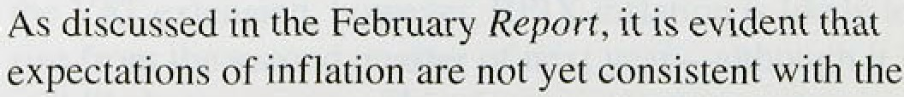

42!’

people have yet to be convinced that the target will be met in the long run. But the longer underlying inflation remains within the target range the more credibility will

Looking to the end of 1994 and beyond, the principal uncertainty concerns the response of domestic factor cost wag+r aod profits—to the loss ofpu hasing power resulting from depreciation of the currency. If total profits and wages rise because of a *volume* effect, rather than an increase in profit margins per unit of output or earnings per head, then the increase in nominal

demand consistent with the monetary stance will lead to rising real activity and continuing low inflation. A continuing determination on the part of the authorities to meet the inflation target will help to ensure that increases in wages and profits are real increases, reflecting higher output and productivity, rather than nominal increases reflecting only higher unit costs. It is vital in this context that the inflation target be seen as a framework for policy over a long period, and that monetary and fiscal policy should be consistent with achieving the target on a sustained basis.





Pi’ice (4.()t)